Learning With Errors Visualization Lab
Applied Mathematics / Computer Science
Name:
Date:
Objective
In this activity, you will use SageMath to explore the Learning With Errors (LWE) problem. You will observe how adding small random error changes modular linear equations and why this makes recovering a secret significantly more difficult.
Learning Objectives
By the end of this activity, you should be able to:
- Explain the components of the LWE equation.
- Describe how random error affects the public outputs.
- Interpret graphical representations of noisy data.
- Explain why recovery the secret becomes computationally difficult.
Background
The simplified LWE equation is
$$b=A∙s+e \left(mod q\right)$$
Where,
- A = Public matrix
- s = Secret vector
- e = Random error vector
- q = Modulus
- b = Public output
Without error:
$$b=A∙s \left(mod q\right)$$
The system behaves more like ordinary linear algebra. When small random error is added, the secret becomes harder to recover.

Attack Methods Comparison
Attack | Main Idea | Works If A is Not Square | Effective on Real LWE
Linear Algebra (matrix inversion) | Compute $A^{-1}b$ | No | Not usually since matrix A is almost never square
Brute Force | Guess every secret | Yes | Only for toy examples
Lattice Reduction LLL/BKZ | Search for lattice vectors | Yes | Yes
BKW | Combine equations to eliminate variables | Yes | Yes
Hybrid | Combine brute force with lattice reduction | Yes | Yes

Part 1: Default Run
Run the SageMath program using the default values.
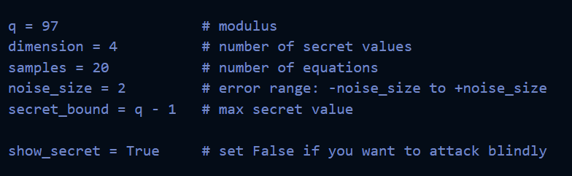
Record and paste a photo of the Outputs (ATTACK METHOD SUMMARY, ATTACK RESULTS, and STUDENT OUTPUT TABLE VALUES):
Quantity | Values
Public Matrix (A), first row | Students record first row from output
Error Values | Student records generated error vector
Clean Outputs | Students record Clean Outputs shown by program
Noisey Outputs | Students record Noisey Outputs shown by program
Fastest Successful Attack | Usually Brute Force, BKW-type Toy Attack, or another successful attack dependent on runtime.

Question 1
What effect does the random error have on the public outputs?
Answer:
- Adds minor changes to outputs.
- It makes recovering the secret harder.
- Perturbs the equations without completely changing them.

Question 2
Why does the Linear Algebra attack Fail in this demonstration?
☐ Because the modulus is too large.
☑ Because the matrix $A$is not square.
☐ Because the secret is too small.
☐ Because brute force is faster.

Question 3
Which attack recovered the secret the fastest?
Answer:
- Depending on their output (look at photo)
- Brute Force
- BKW-Style
- Hybrid Attack
- LLL/Lattice-Style

Part 2: Scatter Plot Analysis
Open and paste photo:
lwe_scatter_plot.png
Insert Plot

Question 2
Describe the relationship between the blue and red.
Answer:
- The red points are slightly shifted.
- The noisy outputs stay close to the clean outputs.
- The two sets follow the same overall pattern.
Open and paste photo:
lwe_clean_va_noisy.png

Question 5
What does the dashed blue line represent?
Answer:
The dashed blue line represents the ideal situation where no error has been added.

Question 6
Why do most of the red points remain close to the dashed blue line?
Answer:
Since the error values are intentionally small. The random error changes each equation only slightly rather than completely altering outputs.

Part 4: Noise Experiment
Change only the noise value and run the program three times.
Noise Size | What happened to the red points? | Was the attack easier or harder?
0 | Red and blue outputs become identical | Very easy
2 | Small difference between outputs | Moderate
8 | Larger difference while still preserving overall patter | Harder

Question 7
Which noise value appeared to provide the least security?
Answer:
Noise = 0

Question 8
Why doesn’t simply increasing the noise forever produce a better cryptosystem?
Answer:
- Too much noise makes decryption difficult.
- Large errors reduce reliability.
- Security and correctness must be balanced.

Final Reflection
In 3-5 sentences, explain why LWE is considered a strong mathematical foundation for post-quantum cryptography. Include one thing you learned from the SageMath demonstrations.
Answer:
- LWE adds a small random error to a system of equations.
- The random error hides the exact relationship between public information and the secret vector.
- The noisy outputs remain close to the clean outputs but no longer exact.
- Ordinary linear algebra cannot directly recover the secret because the matrix may not be square or since the added error prevents exact recovery.
- Recovering the secret requires more advanced techniques like brute-force (for smaller examples), lattice reduction, BKW, or hybrid attacks.
- Real LWE systems use much larger parameters than the classroom.
- LWE is believed to resist attacks from both classical and quantum computers, making it promising foundation for post-quantum cryptography.
- Security comes from balancing small random errors with ability of legit users to still perform the intended computations.

